  

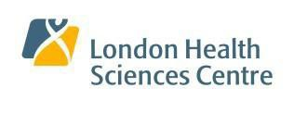

London Imaging Discovery Day

Thursday, June 5, 2025, Full Day

King’s University College

*On behalf of the London Imaging Discovery Day Co-Chairs, Dr. Narinder Paul and Dr. Aaron Fenster…….*

We invite you to participate in the 20th Annual London Imaging Discovery Day (LIDD).

In 2024, we had almost 300 registrants from Western University (including the Department of Medical Imaging and other departments from the Schulich School of Medicine & Dentistry), London Health Sciences Centre, Robarts Research Institute, Lawson Health Research Institute, St. Joseph’s Health Care, London and our community partners in Medical Imaging.

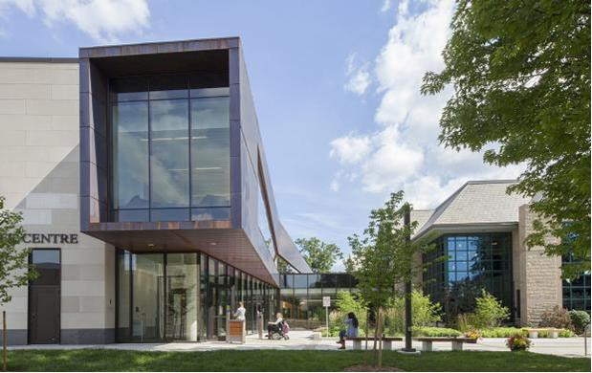This year, we will once again be utilizing the outstanding conference space at Kings University College, in order to accommodate our learners, imaging scientists, technologists, nurses, administrators, Medical Imaging faculty and Industry partners.

The facility has the following:

* Main auditorium that accommodates up to 476 people
* Purpose built presentation rooms for the “theme based oral presentations”
* Central display area for Industry partners
* Ample, free parking.

|  |  |  |
| --- | --- | --- |
| Highlights of LIDD 2024   * 46 theme based oral presentations covering 8 themes in Medical Imaging * 4 invited lecturer presentations/keynote speakers | Peer reviewed scientific awards:   * Magna Cum Laude * Certificate of Merit * Honorable Mention * Tom Monro Award * Best Resident Oral Presentation | Inspirational awards   * Chair’s Award for Inspiration * Annual Award for Academic Excellence * Lifetime Achievement Award |

Kindly mark the date in your calendar.

Looking forward to seeing you all there!

[For more information, please visit our Website here (Registrations, Abstract details, Conflict of Interest Forms).](https://www.schulich.uwo.ca/medimaging/research/london_imaging_discovery_day/index.html)

Warm regards,

Dr. Narinder Paul, *Chair/Chief of Medical Imaging*

and

Dr. Aaron Fenster, *Imaging Director, Robarts Research Institute*